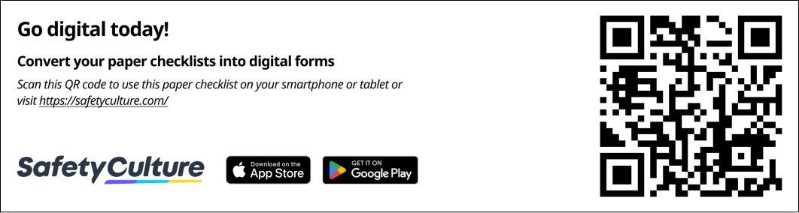

ISO 9001:2015 Lessons Learned Log - Industry Vetted

This log was was developed by our Industry Expert Partner to capture key learnings from projects and process improvements to enhance future performance and compliance with ISO 9001:2015 Clause 10.3 (Continual Improvement).

Title Page

Document number Text answer

* Site Text answer

Created on |  | Date/time
Enter Date and Time:

/ /
: | AM / PM
Prepared by |  | Text answer

Location Text answer

Lessons Learned
Product/Project
Repeat section

Product/Project name Text answer

Product/Project code Select one

[  [ | ] Yes  ] No
[ | ] N/A

Date |  |  |  | Date/time
Enter Date:  / |  | /
Project lead |  |  |  | Text answer

Team members Text answer

Lessons
Repeat section

Category Multiple choice

[ ] Design & Development [ ] Manufacturing Process [ ] Supplier & Materials
[ ] Quality Control & Inspection [ ] Regulatory & Compliance
[ ] Customer Feedback & Complaints [ ] Production Efficiency
[ ] Risk Management
[ ] Supply Chain & Logistics [ ] Testing & Validation
[ ] Other:

Description of issue Text answer

Root causes Text answer

Corrective actions Text answer

Impact Multiple choice

[ ] Quality [ ] Cost
[ ] Efficiency
[ ] Satisfaction [ ] Compliance
[ ] Supply Chain [ ] Training
[ ] Risk
[ ] Environmental [ ] Innovation
[ ] Other:

Preventive actions Text answer

Approvals and Acknowledgement

Team lead Signature

Date: / /

Reviewed by Signature

Date: / /

Prepared by Signature

Date: / /

